DOCUMENTATION
MySQL Assignment 2 – Querying Data
- Distinct Values
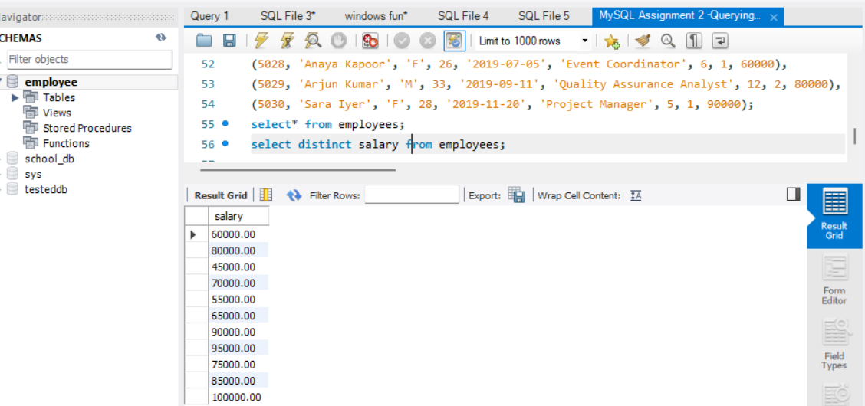
- a query to retrieve distinct salaries from the Employees table.

- Alias (AS)
- Provide aliases for the "age" and "salary" columns as "Employee_Age" and "Employee_Salary", respectively.
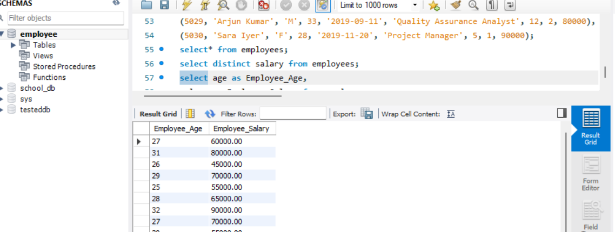

- Where Clause & Operators:
- Retrieve employees with a salary greater than ₹50000 and hired before 2016-01-01.
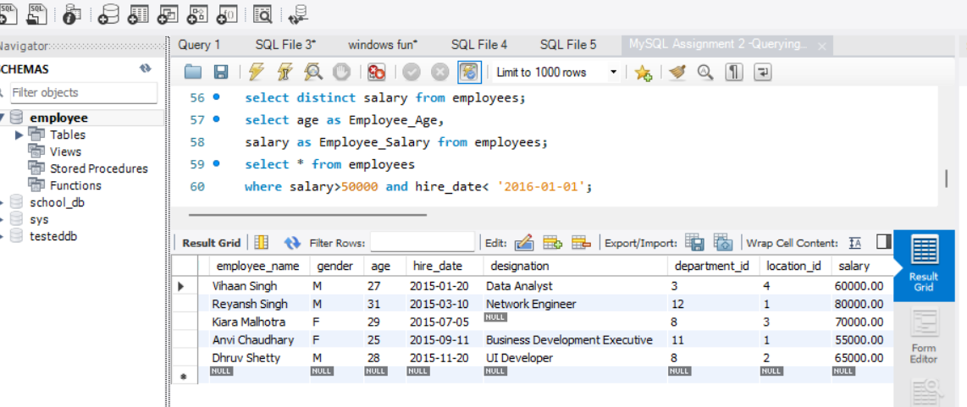
- Find the employee whose designation is missing and fill it with "Data Scientist".
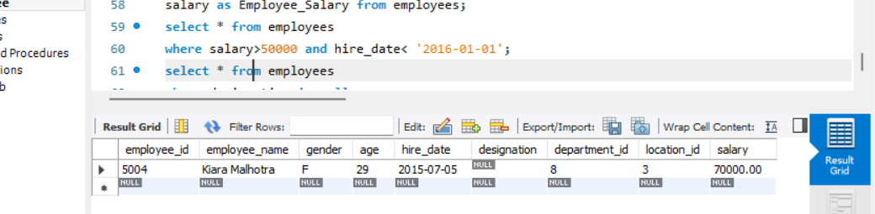
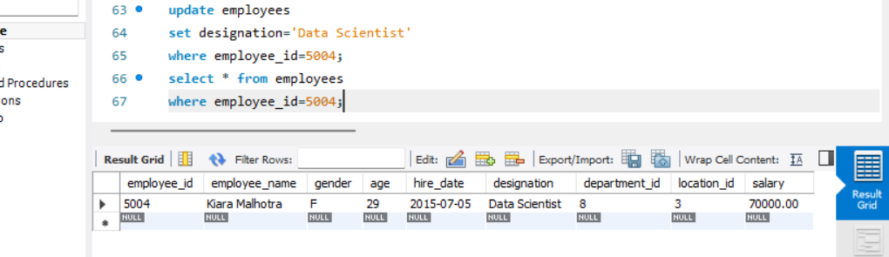

Sorting and Grouping Data

- ORDER BY
Find employees sorted by department ID in ascending order and salary in descending order.
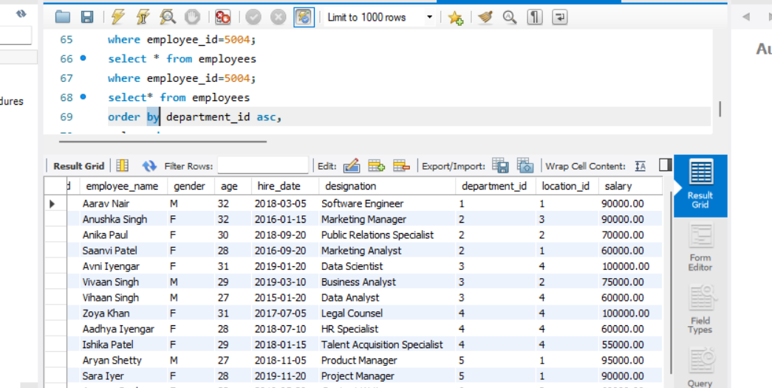
- LIMIT:
Display the first 5 employees hired in the year 2018.

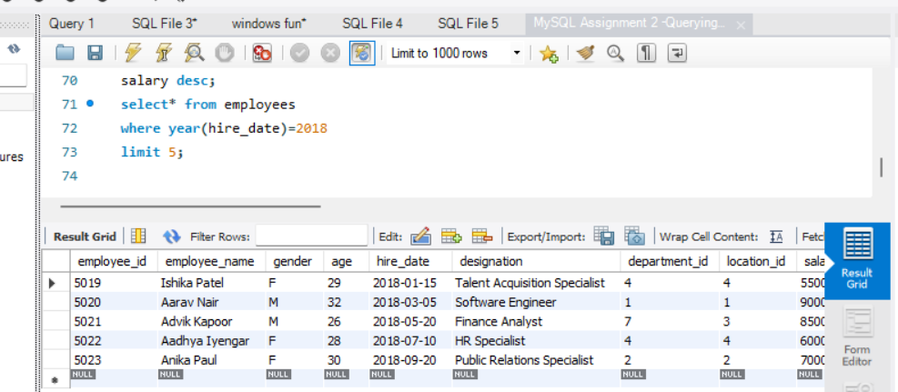

- Aggregate Functions
- Calculate the sum of all salaries in the Finance department.

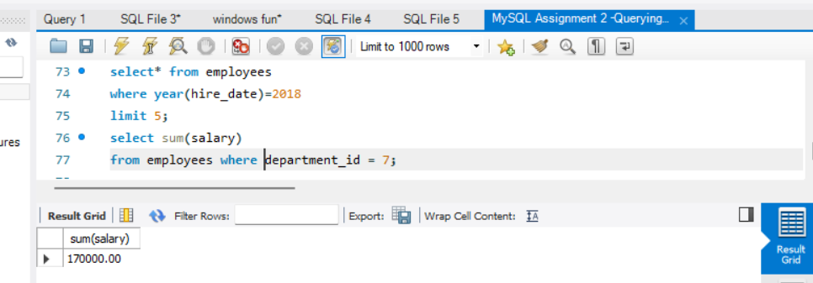

- Find the minimum age among all employees.

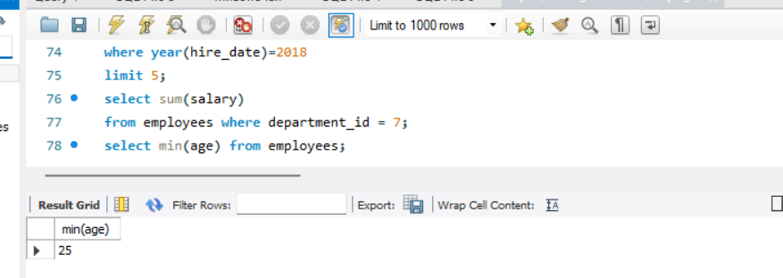

- GROUP BY:
- List the maximum salary for each location.
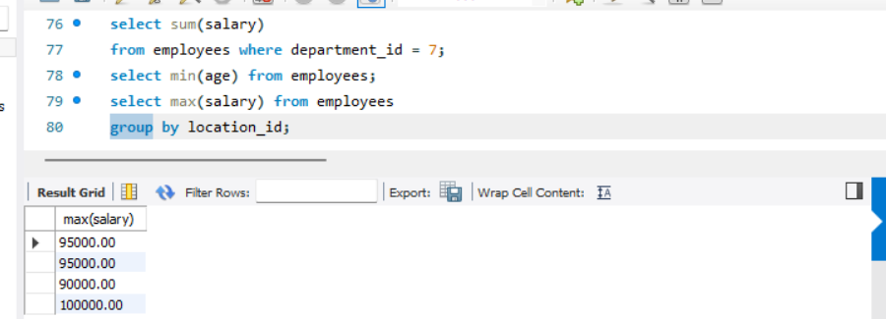
- Calculate the average salary for each designation containing the word 'Analyst'.

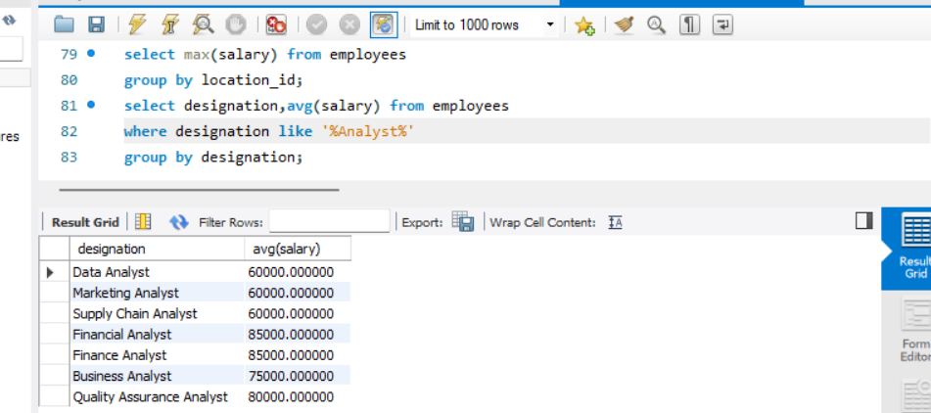

- HAVING
- Find departments with less than 3 employees.

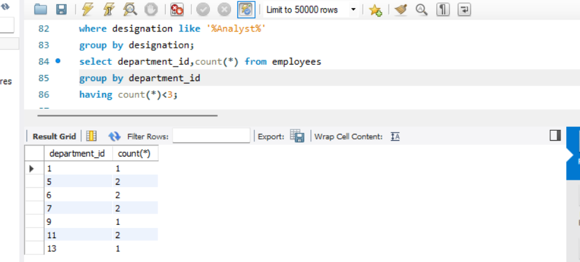
- Find locations with female employees whose average age is below 30.
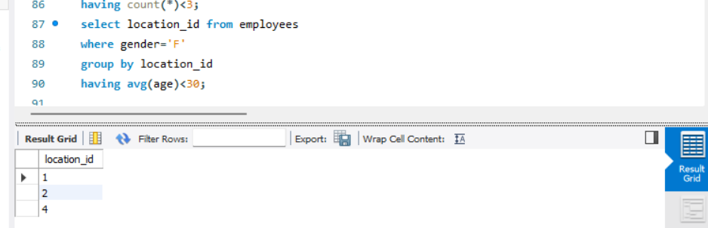

JOINS

- INNER JOIN
- List employee names, their designations, and department names where employees are assigned to a department.

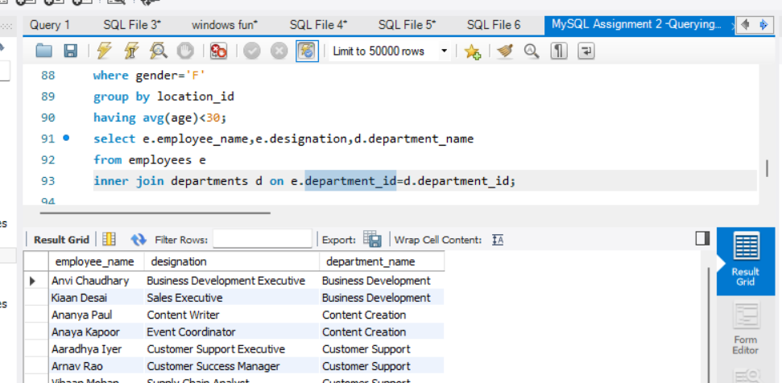
- LEFT JOIN
- List all departments along with the total number of employees in each department, including departments with no employees.
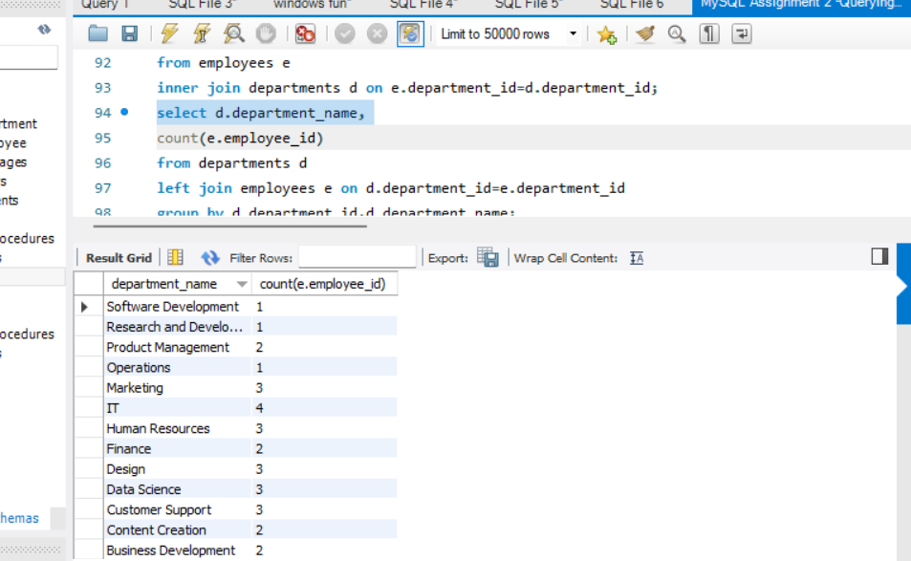

- RIGHT JOIN
- Display all locations along with the names of employees assigned to each location. If no employees are assigned to a location, display NULL for employee name.

